Creating a Rule in Outlook

Step 1: Select **File**.

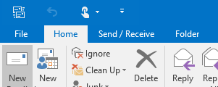

Step 2: Select **Manage Rules & Alerts**.

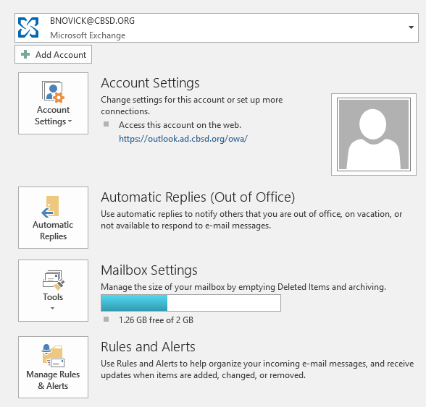  
  
Step 3: Select **New Rule.**

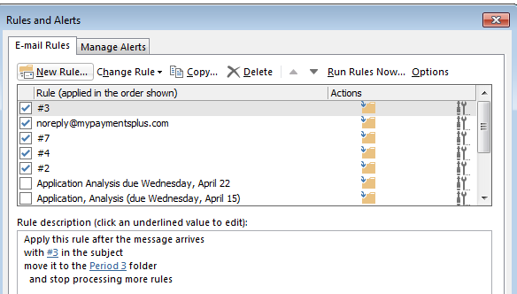

Step 4: Select **Move message with specific words in the subject to a folder.**

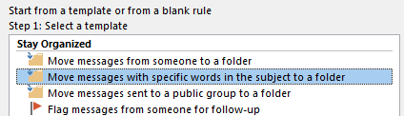

Step 5: Select **specific word** in the subject. (Note: This selection is on the bottom of the window for Step 4)

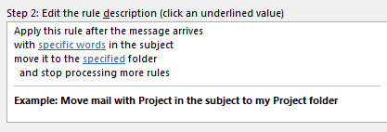

Step 6: Click **Add.** Click **Ok.**

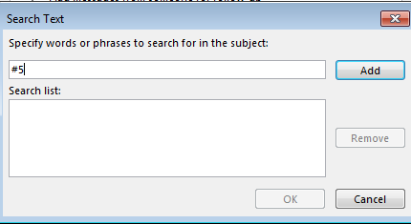

Step 7: Click **specified** folder



Step 8: Click **New** folder. Once you create your folder, click **OK**.

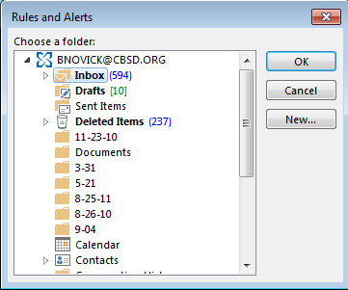

Step 9: Click **Next.** Click **Next** again. Click **Finish.** Click **OK.**